# MINI PROJECT - I

## (2021-2022)

**Bookish World PROJECT REPORT**



Institute of Engineering & Technology

## SUBMITTED BY:

### Devang Tiwari (191500253)

### Hitesh Panwar (191500350)

### Keshav Dev Tiwari (191500392)

### Rajya Vardhan (191500632)

### Sahil Vishwakarma (191500693)

### **Under the Supervision of**

### **Md. Farmanul Haque**

### **Technical Trainer**

### **Department of Computer Engineering & Applications**

|  |
| --- |
| **Table Of Contents** |
| **Certificate 3**  **Acknowledgement 4**  **Abstract… 5** |
| **1. Introduction 6** |
| 1.1 Overview 6 |
| 1.2 Motivation 6 |
| 1.3 Problem Statement 7 |
| 1.4 Objective… 7 |
| **2. Software Requirement Analysis 8** |
| 2.1 System Analysis 8 |
| 2.2 Role of System Analyst 8 |
| 2.2.1 Main roles of System Analyst 8 |
| 2.3 Users 9 |

* 1. Methodology 9
  2. Dependencies /External Systems 10
  3. Hardware and Software Requirements 11
  4. Technology Used 12
  5. DFD 13
  6. Use-case Diagram 14

1. Implementation details 15
2. Contribution Summary 18
3. Project Work 19
4. Future Scope… 29
5. Conclusion 30
6. Reference 31

## Certificate

This is to certify that Devang Tiwari, Hitesh Panwar, Keshav Dev Tiwari, Rajya Vardhan, Sahil Vishwakarma - students of B-Tech (CSE) 3rd year have successfully completed the **MINI PROJECT - I** named **Bookish World** under the Guidance of **Md. Farmanul Haque** during 2020- 2021.

Signature:

**Md. Farmanul Haque**

(Mentor)

## Acknowledgement

It gives us a great sense of pleasure to present the synopsis of BTech Full Stack Project **(Bookish World)** undertaken during B-Tech IIIrd Year. This project in itself is going to be an acknowledgement to the inspiration, drive and technical assistance that has motivated individuals like us.

We owe special debt of gratitude to **Md. Farmanul Haque,** Technical Trainer, Department of CEA, for providing us with an encouraging platform to develop this project, which thus helped us in shaping our abilities towards a constructive goal and for his constant support and guidance to our work. His sincerity, thoroughness and perseverance is been a constant source of inspiration for us. We believe that he will shower us with all his extensively experienced ideas and insightful comments at different stages of the project & also guide us about the latest industry-oriented technologies.

We would also like to acknowledge the contribution of all faculty members of the department for their kind guidance and co-operation.

### Devang Tiwari (191500253)

### Hitesh Panwar (191500350)

### Keshav Dev Tiwari (191500392

### Rajya Vardhan (191500632)

### Sahil Vishwakarma (191500693)

## Abstract

In this cut throat competition, full stack development is one of those fields that is experiencing great demand in IT industries. It has gained a lot of scope in the top-notch industries. Therefore, being a Computer Science student, it becomes quite necessary to learn such full stack technologies in order to increase one’s career prospects. For this, it is important to have practical knowledge of languages and build projects that can be utilized and worked upon in future and among such projects is “Bookish World”

The main aim of this project is to connect all the book lovers and avid readers out there, who then share their book lists and reviews. Also, this platform will give readers a new perspective around the books that they have read, helping them understand the aspects that they never considered. The key components of Bookish World are: (i) Explore Book Titles (ii) Add New Book Title

* There are following users: Readers
* Readers can add new titles, like posts from other readers, read such book titles and delete their posted titles.
* They can sign up and sign in using google account as well as credentials.

## Introduction

* 1. **Overview**
     + Software and Hardware Requirements, corresponding DFD’s and Use Case Diagrams have been organized in this report. Along with these designs, this report also contains the essential data of this project.
     + The complete description of the website followed by the functionalities has been listed initially. Later on, the Webpage has been described diagrammatically with the help of different designing tools like Data Flow Diagram, Use Case Diagram.

## Motivation

In this cut throat competition, full stack development is one of those fields that is experiencing great demand in IT industries. It has gained a lot of scope in the top-notch industries. Therefore, being a Computer Science student, it becomes quite necessary to learn such full stack technologies in order to increase one’s career prospects. For this, it is important to have practical knowledge of languages and build projects that can be utilized and worked upon in future and among such projects is “Bookish World”.

## Problem Statement

In this digital era where people share their hobbies like dance, music etc, there comes a need to provide an open platform to all those readers who want to explore new book titles every day and share their aspects regarding a book. This idea has led to building book-specific social media platform: Bookish World, where people can connect over poetry, literature, blogs, articles, quotes, scriptures- writings that are worth sharing.

## Objective

The main aim of this project is to connect all the book lovers and avid readers out there, who then share their book lists and reviews. Also, this platform will give readers a new perspective around the books that they have read, helping them understand the aspects that they never considered. The key components of Bookish World are: (i) Explore Book Titles (ii) Add New Book Title

* There are following users: Readers
* Readers can add new titles, like posts from other readers, read such book titles and delete their posted titles.
* They can sign up and sign in using google account as well as credentials.

## Software Requirement Analysis

* 1. **System Analysis**

System analysis is a process of collecting and interpreting facts, identifying the problems, and decomposition of the system into its components.

It is a process of studying a system in order to define its goals or purposes and to discover operations and procedures for accomplishing them most efficiently.

## Role of System Analyst

The system analyst is a person who is thoroughly aware of the system and guides the system development project by giving proper directions. He is an expert having technical and interpersonal skills to carry out development tasks required at each phase.

## Main Roles of System Analyst:

* + - * Defining and understanding the requirement of user through various fact finding techniques.
      * Prioritizing the requirements by obtaining user consensus.
      * Maintains analysis and evaluation to arrive at appropriate system which is more user friendly.
      * Draw certain specifications which are easily understood by users and programmer in precise and detailed form.
      * Implement the logical design of system which must be modular.

## Users

The Users of this website would be the Readers who want to add book title or want to read book titles posted by another readers. They can also like those posts and have facility to sign up and sign in using google account or credentials.

## Methodology

Our methodology is designed to help you take maximum advantage of the internet technologies. It incorporates all aspects related to our website and allows us to ensure that the final product is of the highest standards. Below are the steps we will take to ensure that all our deliverables are completed in time, within budget also we will try to solve each and every problem efficiently.

### Requirements analysis

The first step for us is to analyze the target market’s requirements who will be visiting our website, what will be the purpose of their visit, what is the primary goal of our website, how can the users benefit from it. Many such questions are analyzed for the need’s analysis stage.

If we are given access to the current website statistics, we would also like to analyze our current page views, average user time spent on the site, top landing pages, existing search engine rankings, existing bounce rates and many such factors. We analyze our online target audience and assess our differentiation strategy to best attract and retain our online visitors.

Our website should also undergo comprehensive search engine analysis twice during the course of the project; once during this stage and once again after the deployment (Go Live phase) of our website.

### Website handover

Once the site is setup on our destination server, upon your approval we make the website live. One final set of testing is done on the live website for the quality assurance purposes. We then hand over the control of the site to you.

## Dependencies/External Systems

### User Interfaces:

Bookish World website shall permit complete navigation; including all the functionalities described above, starting from seeing the posts published by other readers to adding new book title and also deleting them.

### Hardware Interfaces:

There are two external machines/devices used by the website, each related to a user interface. These are – a machine at the admin end hosting the website and a PC at readers’s end who wants to read about popular book titles as well as share their experience by adding new book title. The devices at the user end behave as terminals. Also capable of taking user input.

## Hardware Requirement (Minimum)

* 4 GB RAM
* Dual Core Processors
* Internet Connections

## Software Requirement -

* SYSTEM SOFTWARE
  + Operating System (Windows 7, Linux)
* APPLICATION SOFTWARE
  + Tools: Visual Studio Code Editor
  + Front End Technologies: React JS
  + Back End Technologies: Node JS, Express JS, Mongo DB

## Technology Used

* **React JS**: It is an [open-source,](https://en.wikipedia.org/wiki/Open-source) [front end,](https://en.wikipedia.org/wiki/Front_end_and_back_end) [JavaScript library](https://en.wikipedia.org/wiki/JavaScript_library)[[3]](https://en.wikipedia.org/wiki/React_(JavaScript_library)#cite_note-react-3) for building [user interfaces](https://en.wikipedia.org/wiki/User_interfaces) or UI components.
* **Node JS**: Node.js is a[n open-source,](https://en.wikipedia.org/wiki/Open-source_software) [cross-platform,](https://en.wikipedia.org/wiki/Cross-platform) [back-end](https://en.wikipedia.org/wiki/Front_end_and_back_end) [JavaScript](https://en.wikipedia.org/wiki/JavaScript) [runtime environment](https://en.wikipedia.org/wiki/Runtime_environment) that runs on the [V8 engine](https://en.wikipedia.org/wiki/V8_(JavaScript_engine)) and executes JavaScript code outside a [web browser.](https://en.wikipedia.org/wiki/Web_browser)
* **Express JS**: Express is [a back end](https://en.wikipedia.org/wiki/Front_end_and_back_end) [web application framework](https://en.wikipedia.org/wiki/Web_application_framework) for [Node.js,](https://en.wikipedia.org/wiki/Node.js) released as [free and open-source software](https://en.wikipedia.org/wiki/Free_and_open-source_software) under the [MIT License.](https://en.wikipedia.org/wiki/MIT_License) It is designed for building [web applications](https://en.wikipedia.org/wiki/Web_application) and [APIs.](https://en.wikipedia.org/wiki/API)
* **MongoDB**: MongoDB is a [source-available](https://en.wikipedia.org/wiki/Source-available) [cross-platform](https://en.wikipedia.org/wiki/Cross-platform) [document-oriented](https://en.wikipedia.org/wiki/Document-oriented_database)  [database](https://en.wikipedia.org/wiki/Document-oriented_database) program. Classified as a [NoSQL](https://en.wikipedia.org/wiki/NoSQL) database program, MongoDB uses [JSON](https://en.wikipedia.org/wiki/JSON)-like documents with optional [schemas.](https://en.wikipedia.org/wiki/Database_schema)

# LEVEL 0 DFD

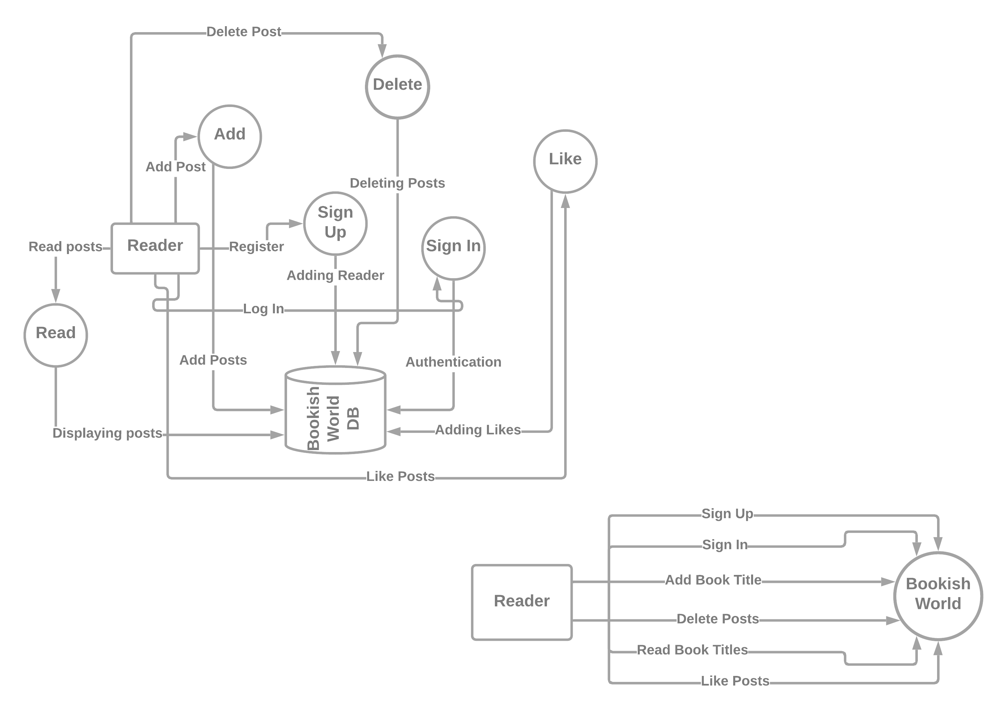

**LEVEL 1 DFD**



**USE-CASE DIAGRAM**

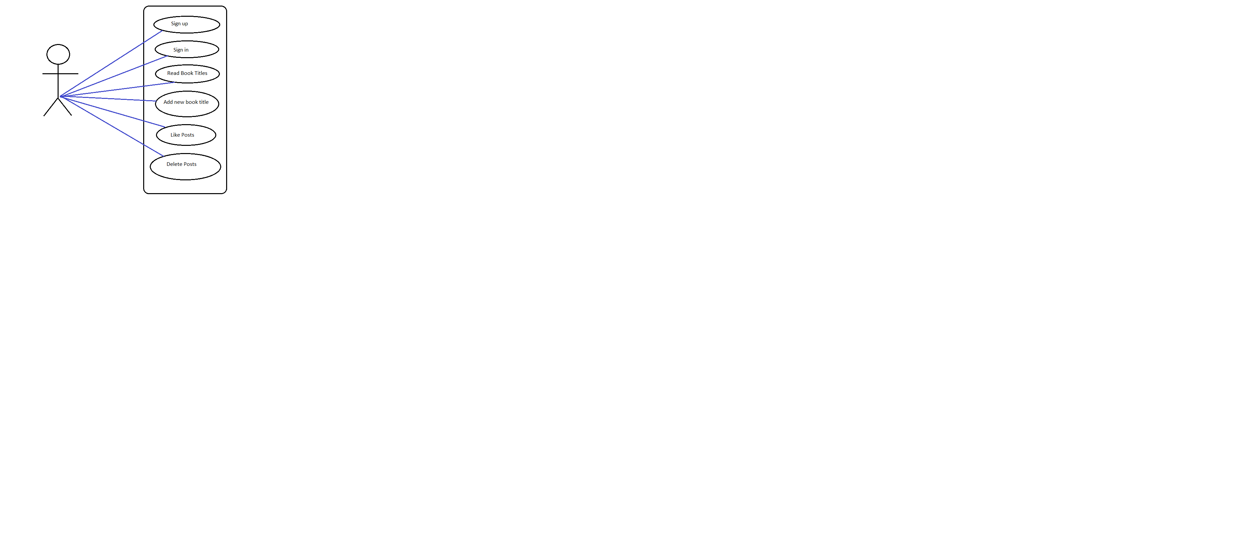

## Implementation Details

This system is intended to develop an open platform for all readers and book lovers where they get to explore new book titles and their aspects and description. This will also help them to share their own aspect for a particular book.

Functionalities are:

* + Using this platform, we can view or add recent/trending book titles.
  + This website contains a dashboard containing posts shared by reader across the globe.
  + Users need to register in order to share or like posts.
  + The user can login or sign up using their credentials or google account.
  + The user can like other’s posts or add/delete their posts.

## Modules Included

* Sign Up form – Sign up using credentials or Google account.
* Sign In form – Sign in using credentials or Google account.
* Bookish World Dashboard – Section where readers have shared their book titles that can be liked by other readers.
* Add Book form – Form to add your own book title along with its description and hashtags.

## Project Work (Desktop View):

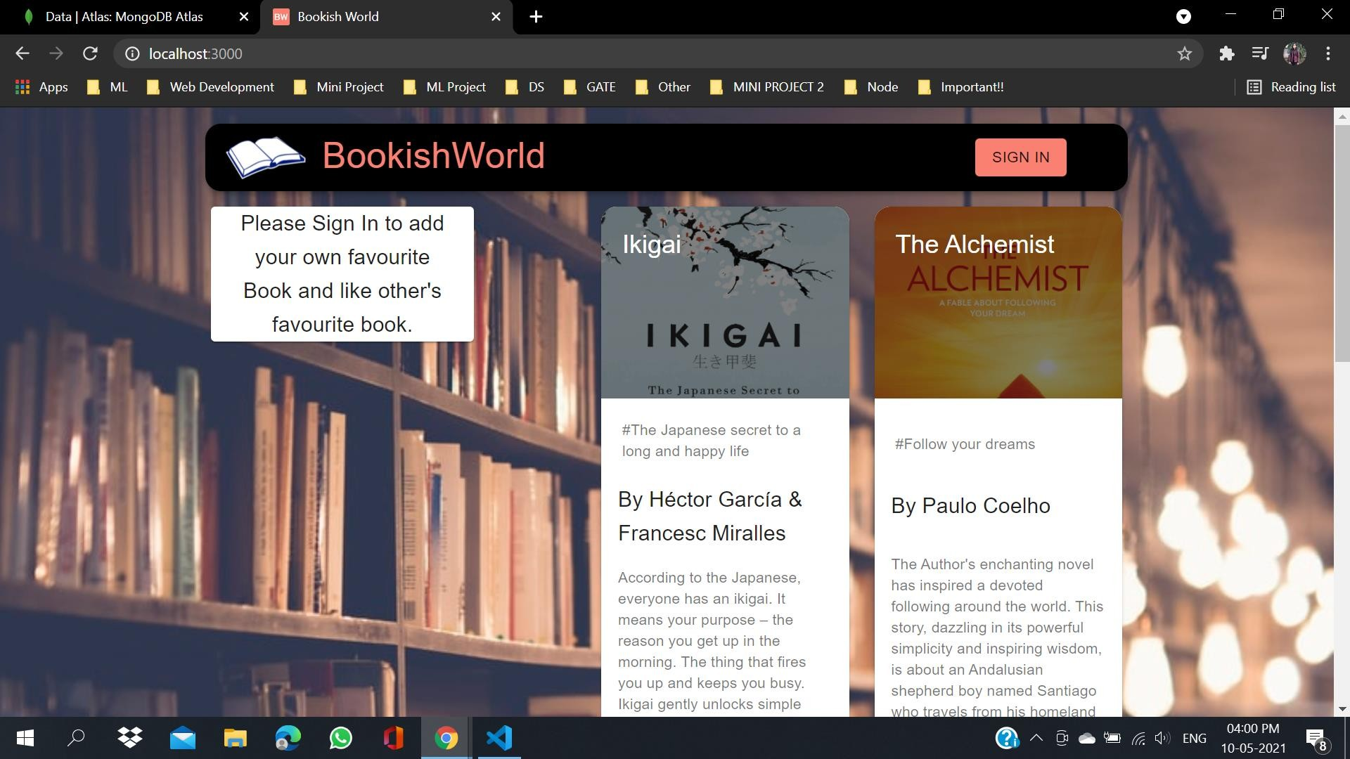

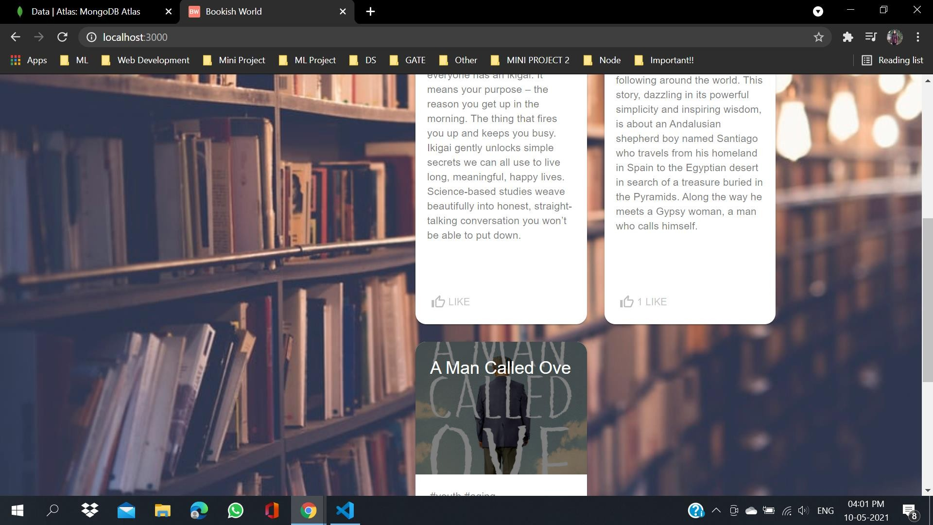

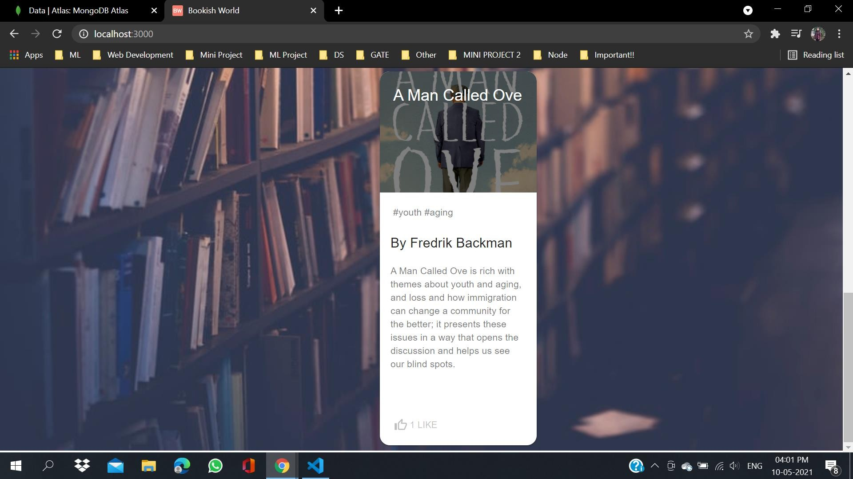

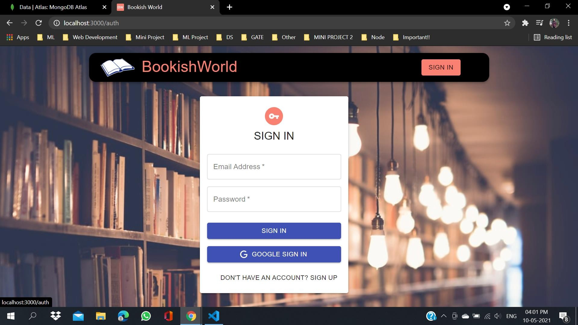

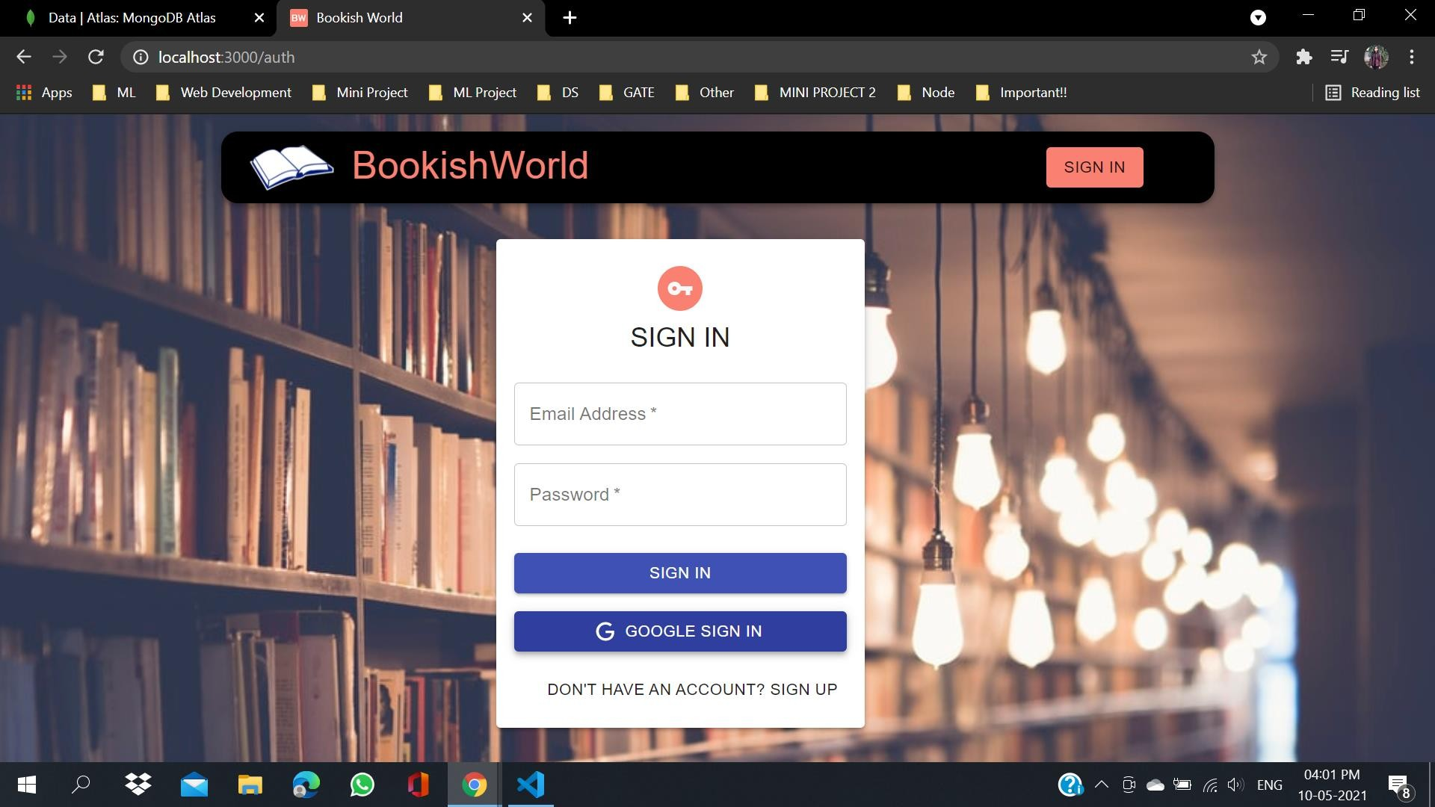

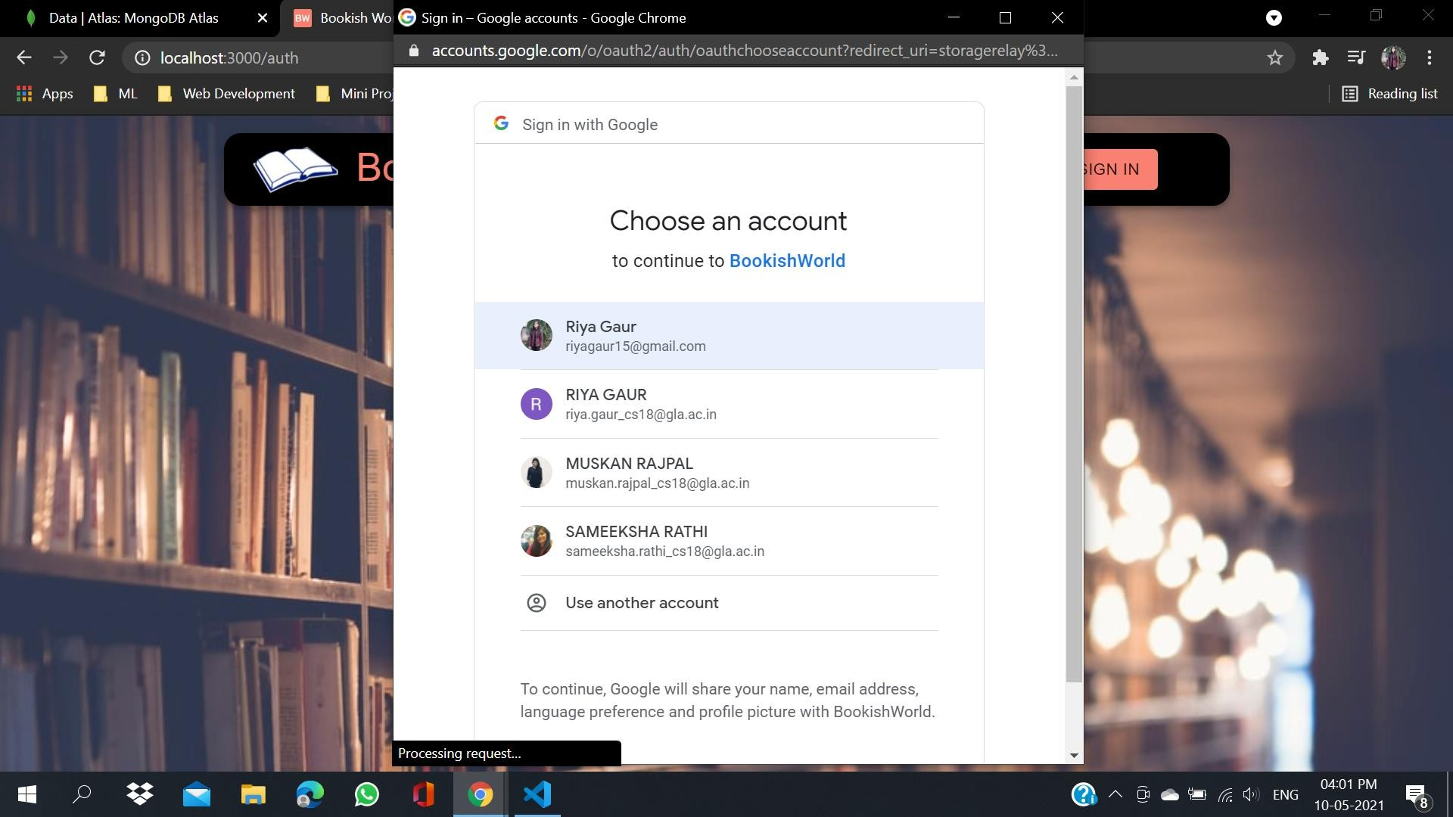

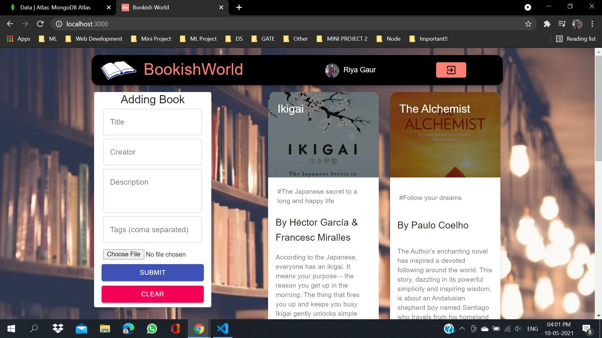

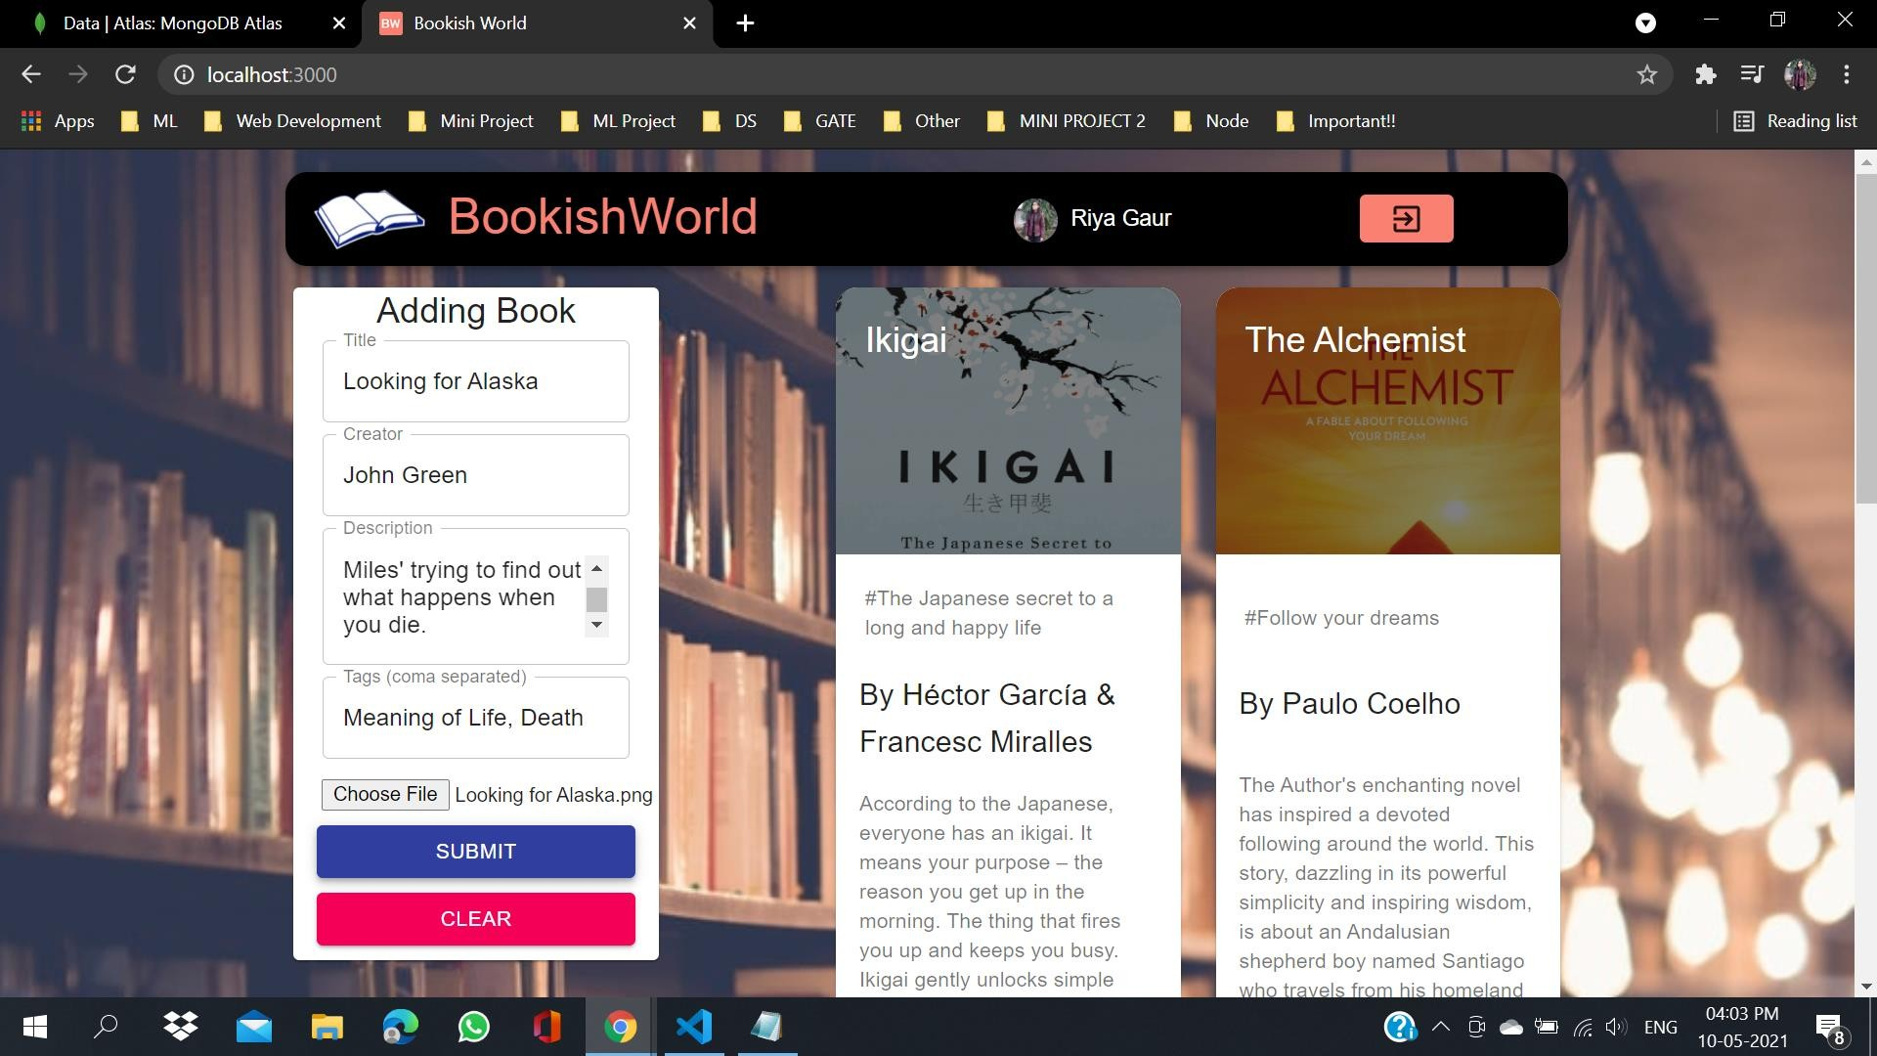

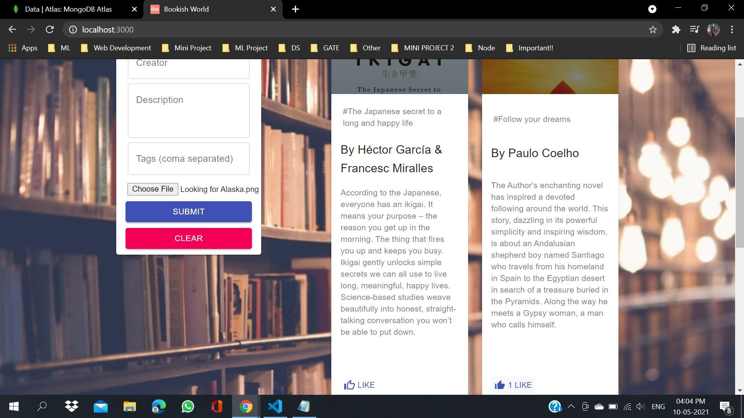

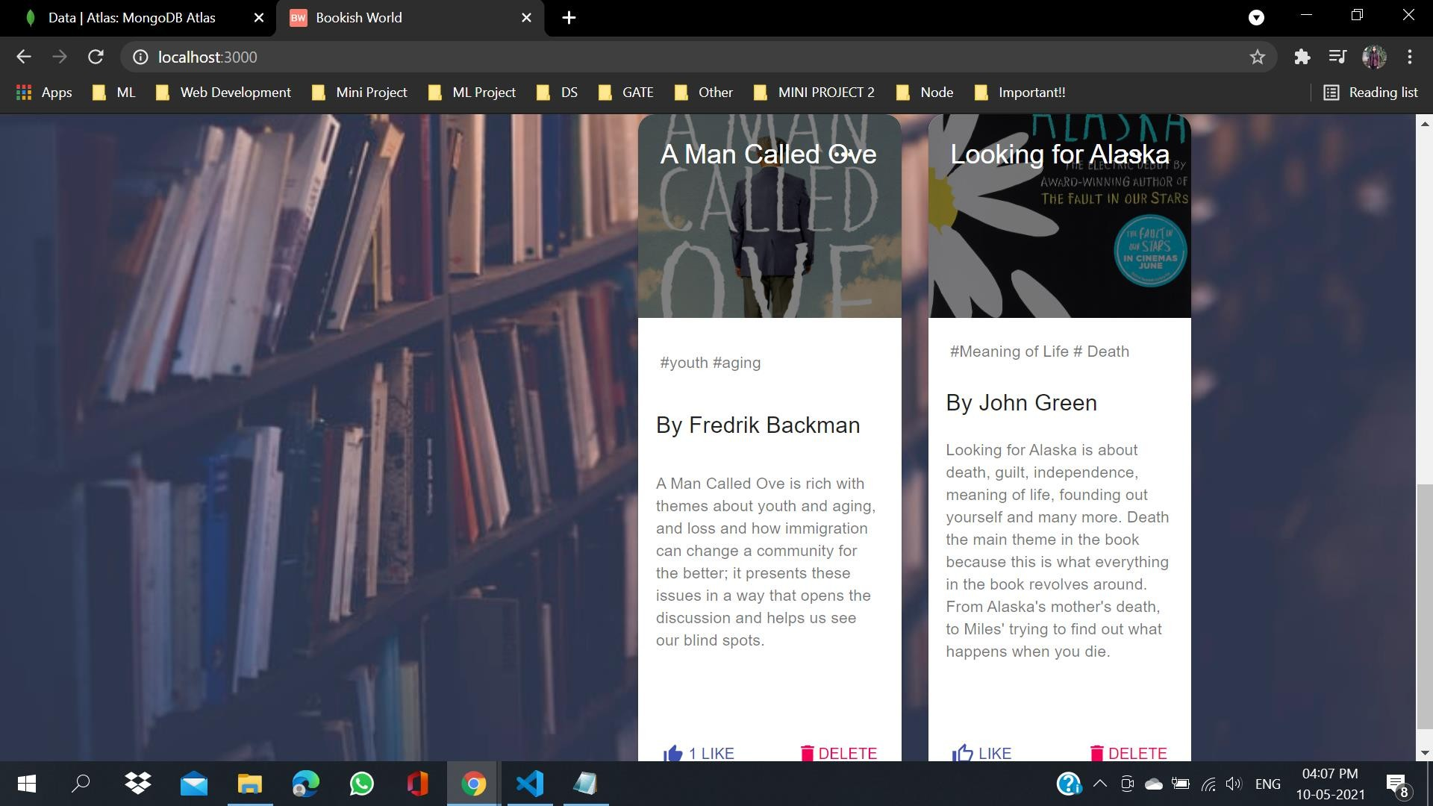

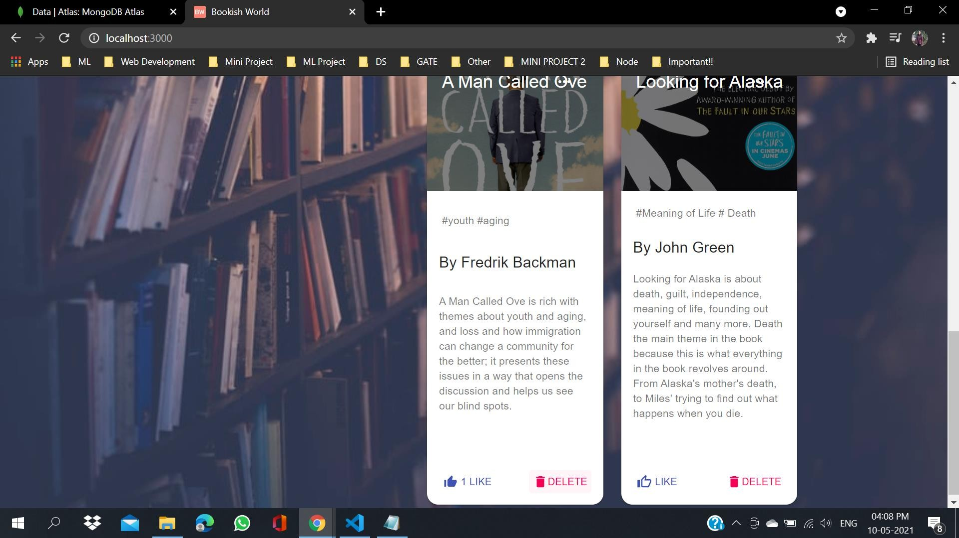

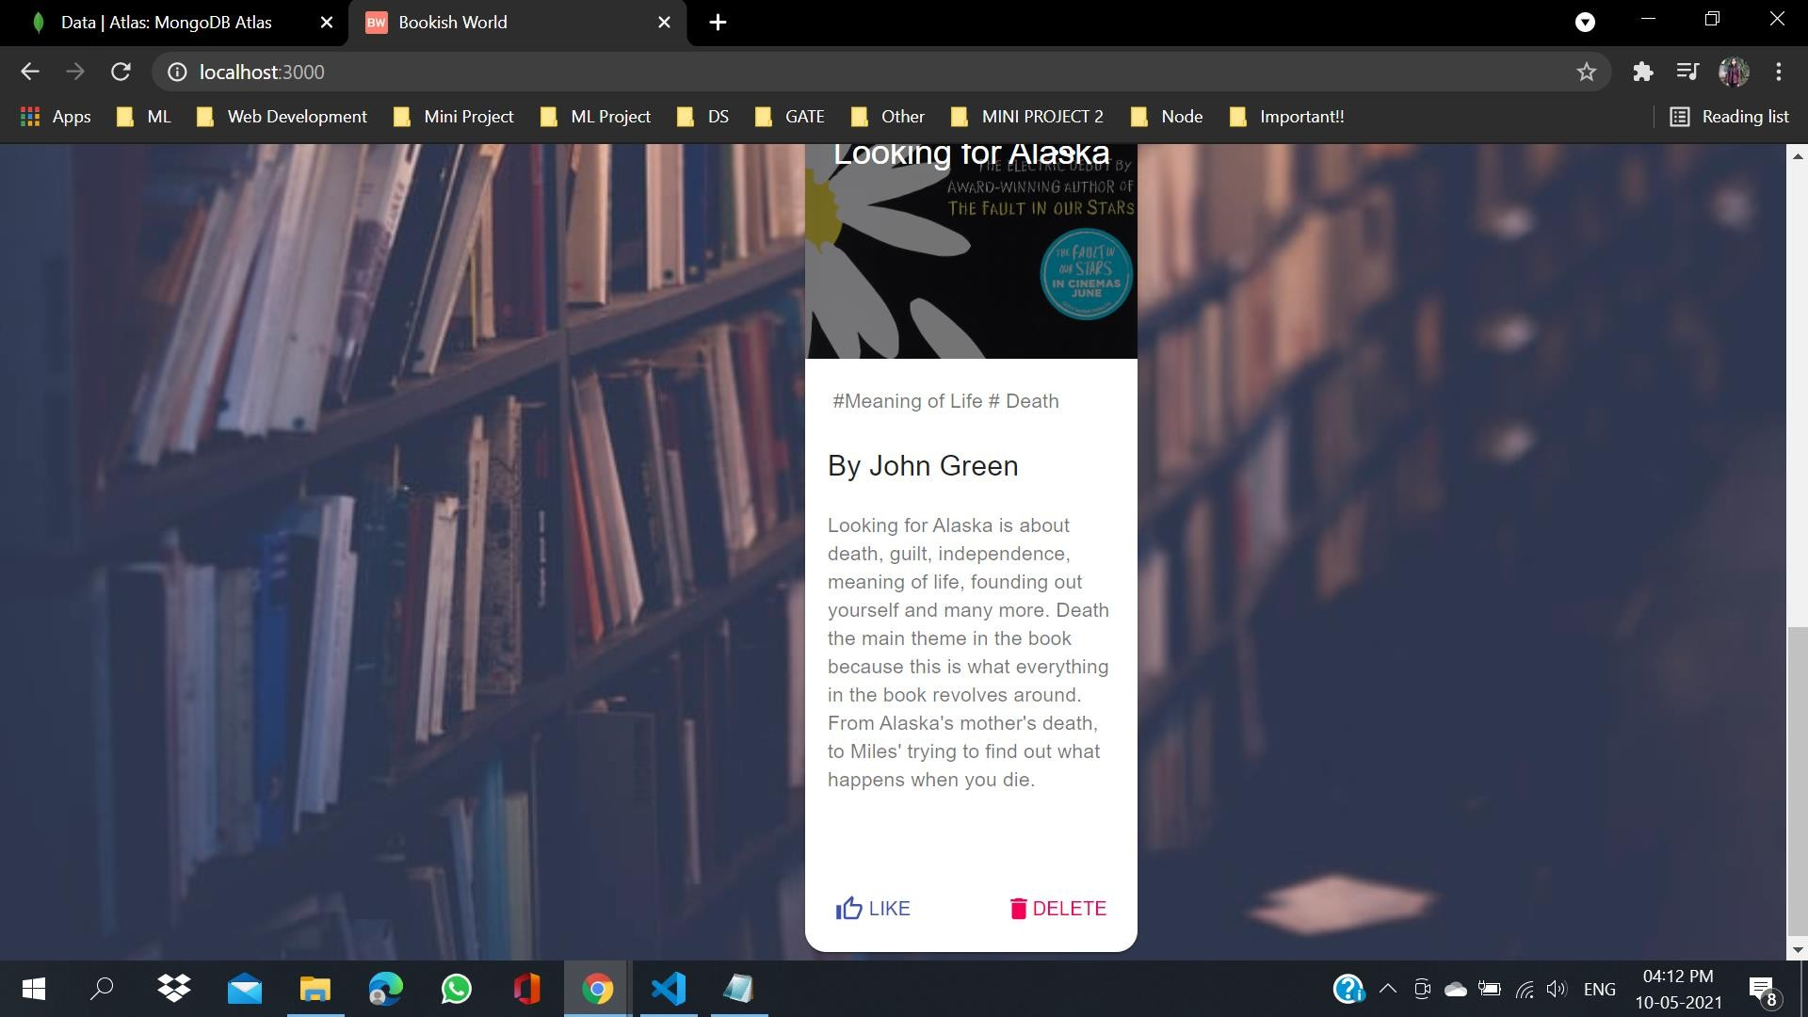

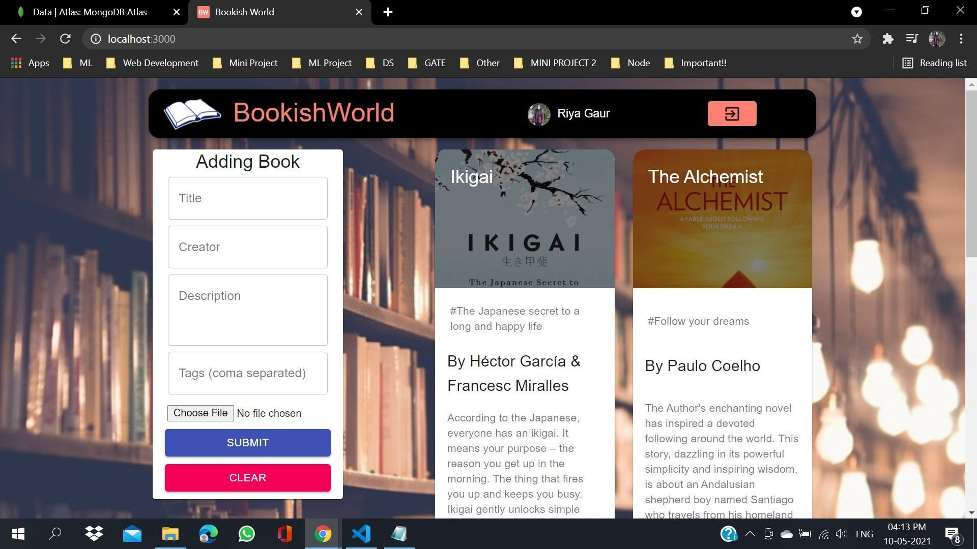

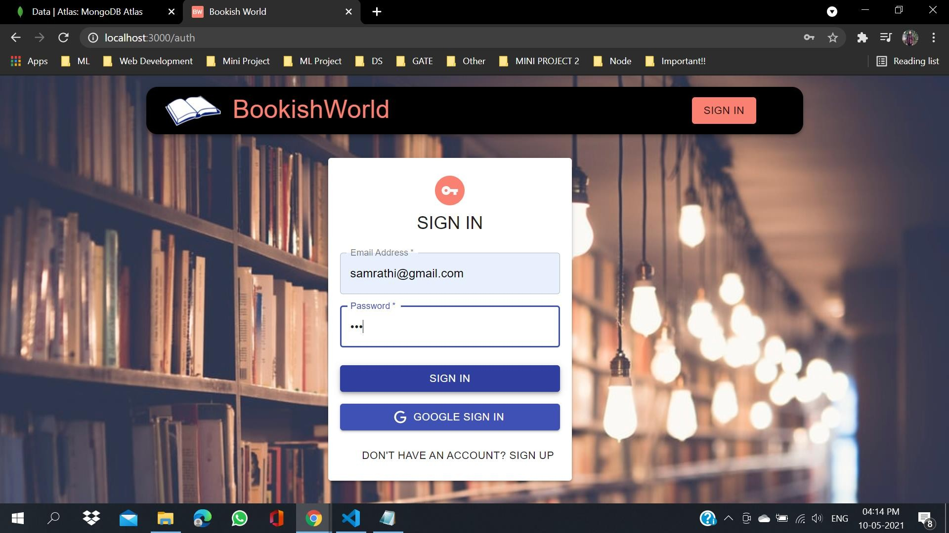

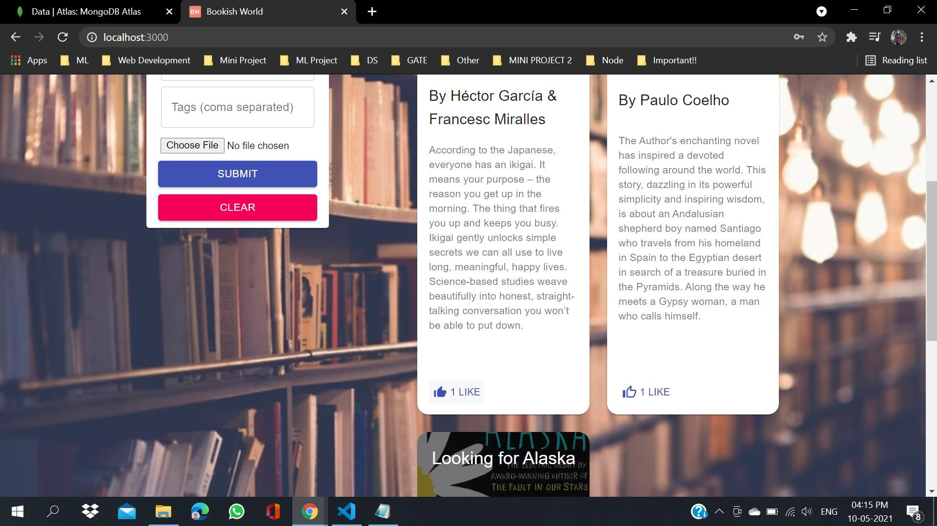

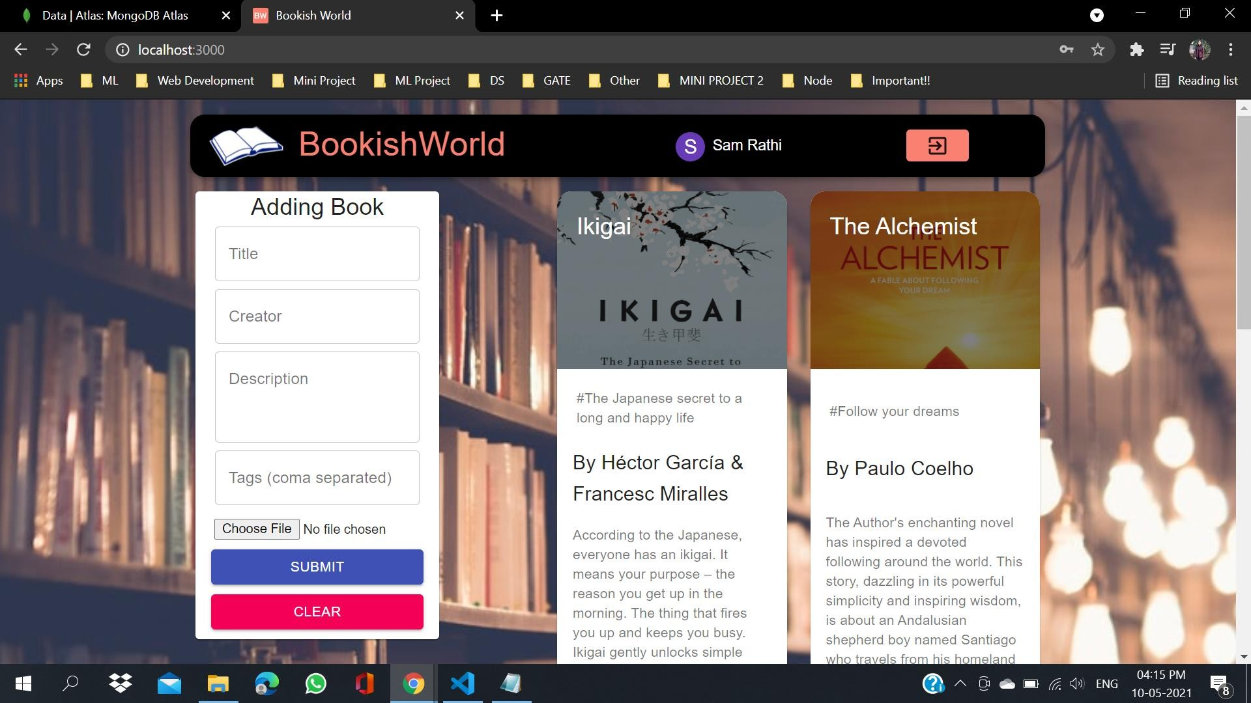

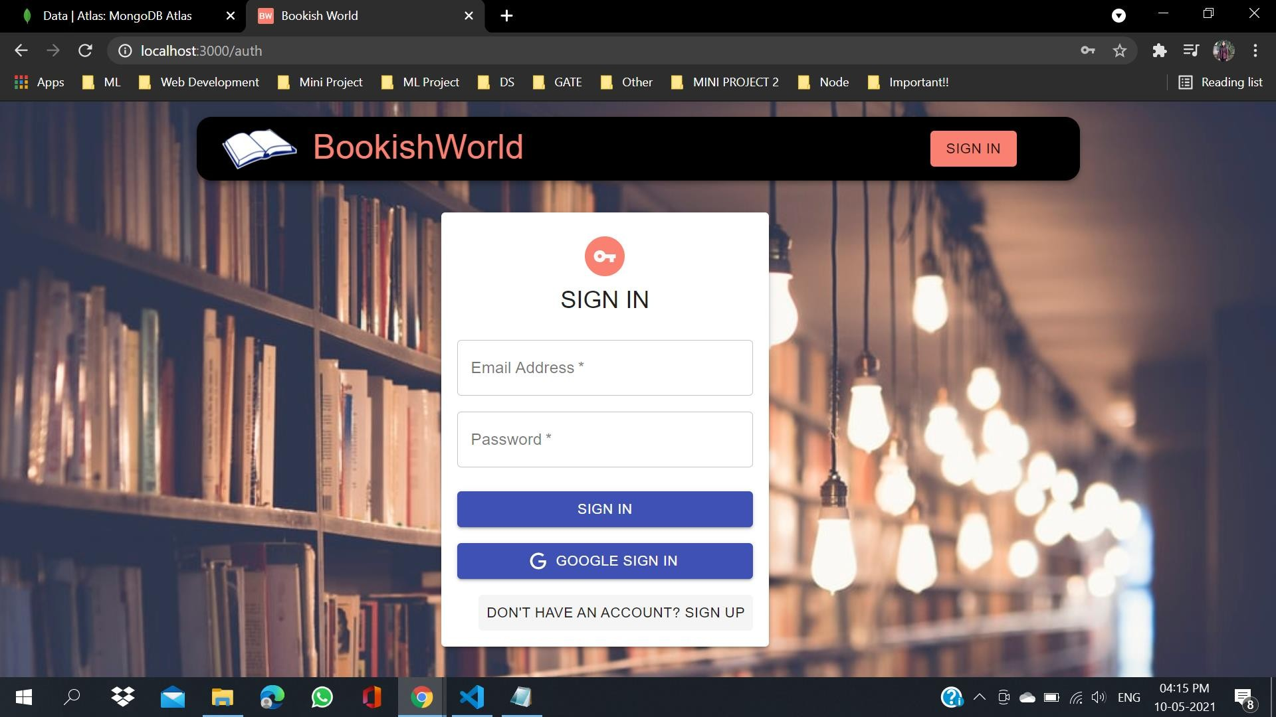

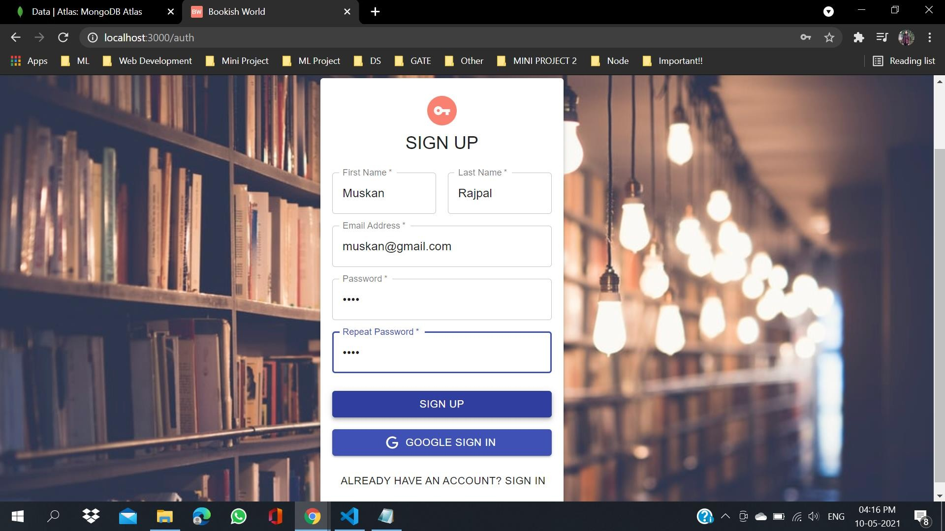

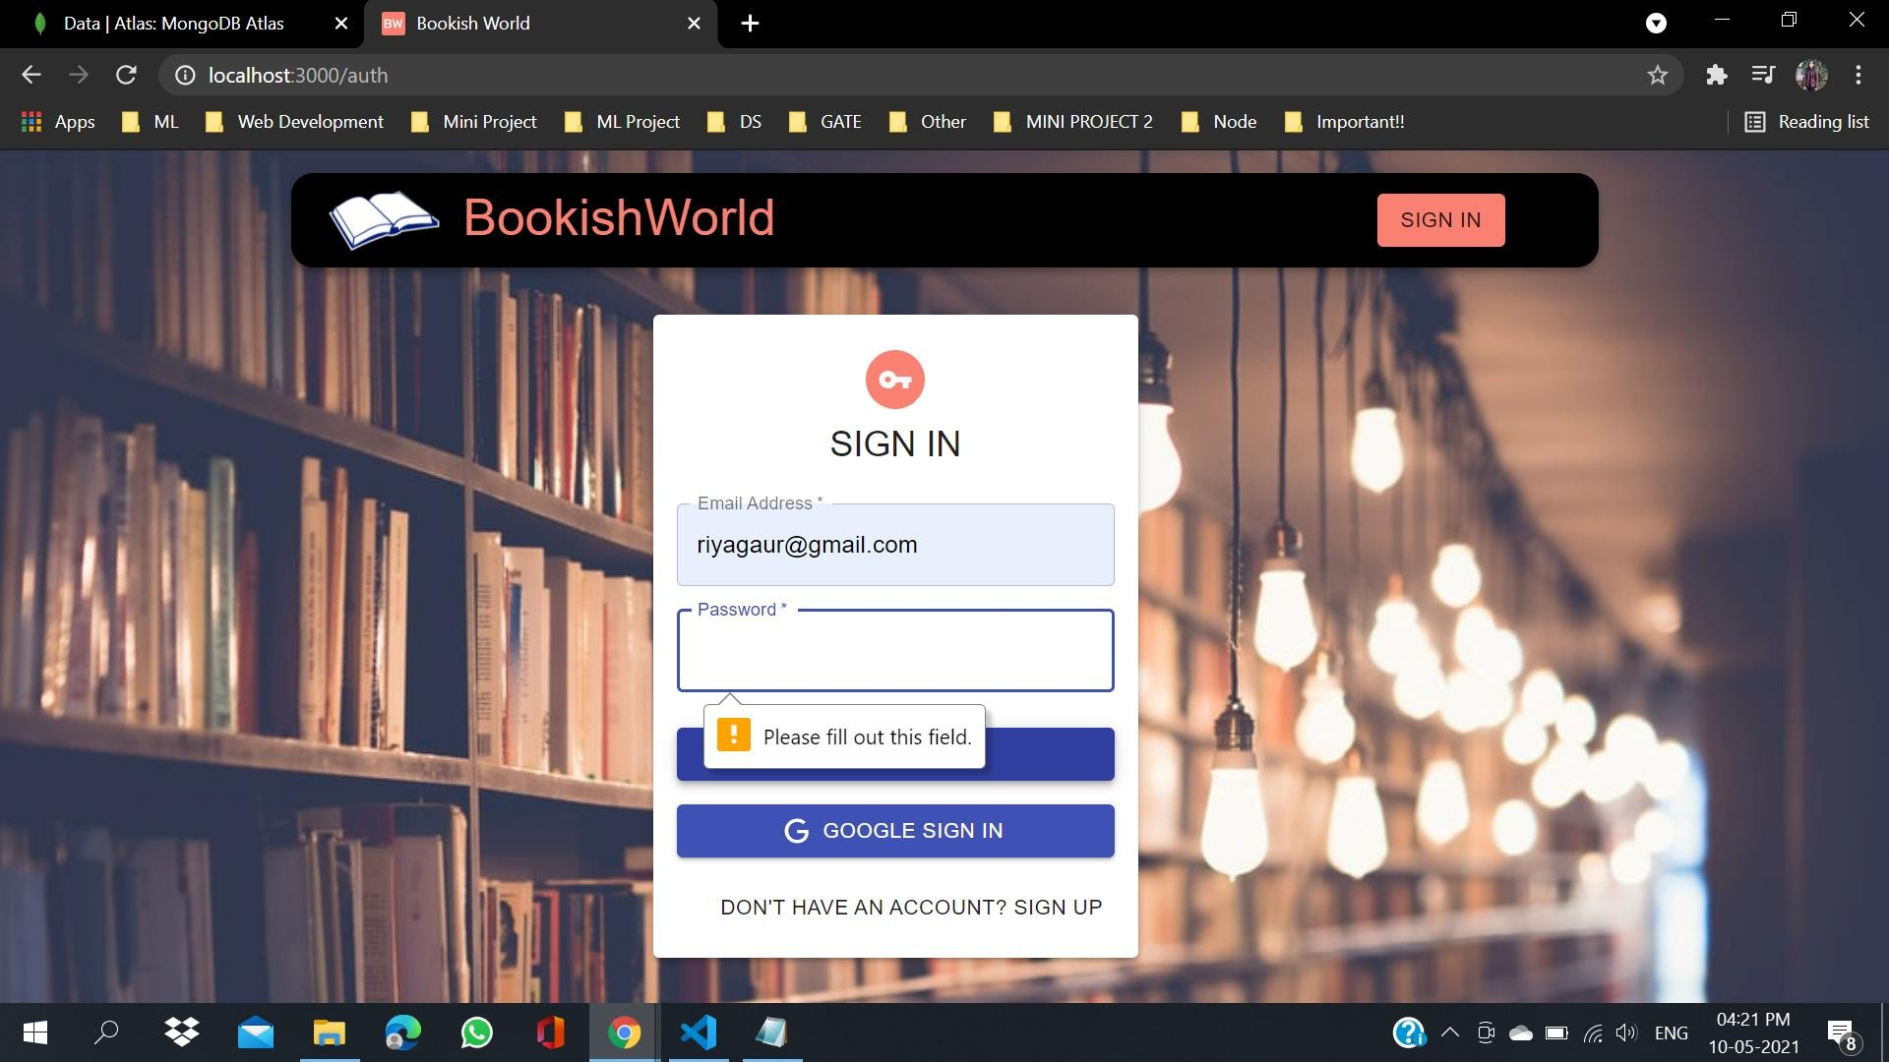

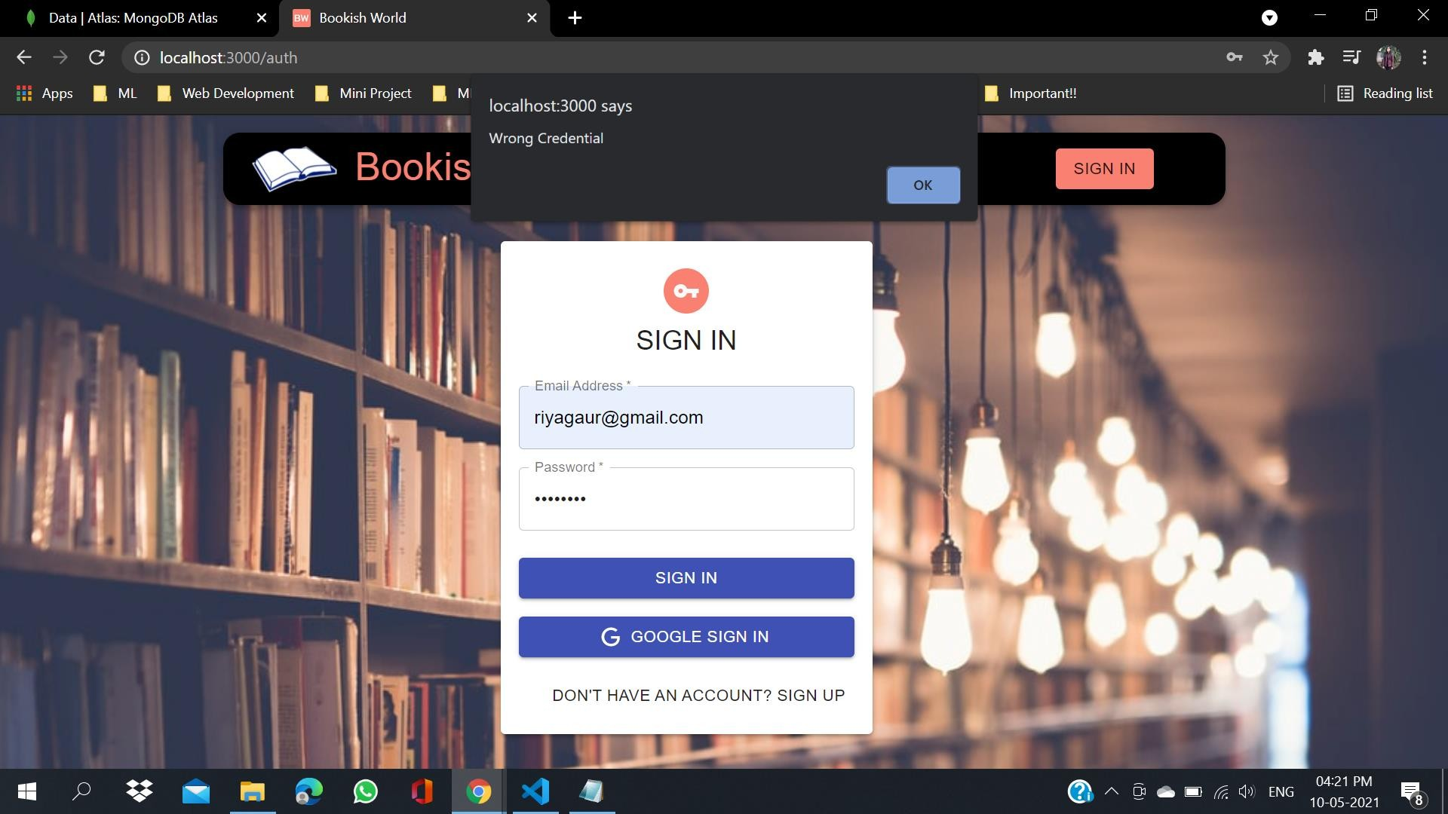

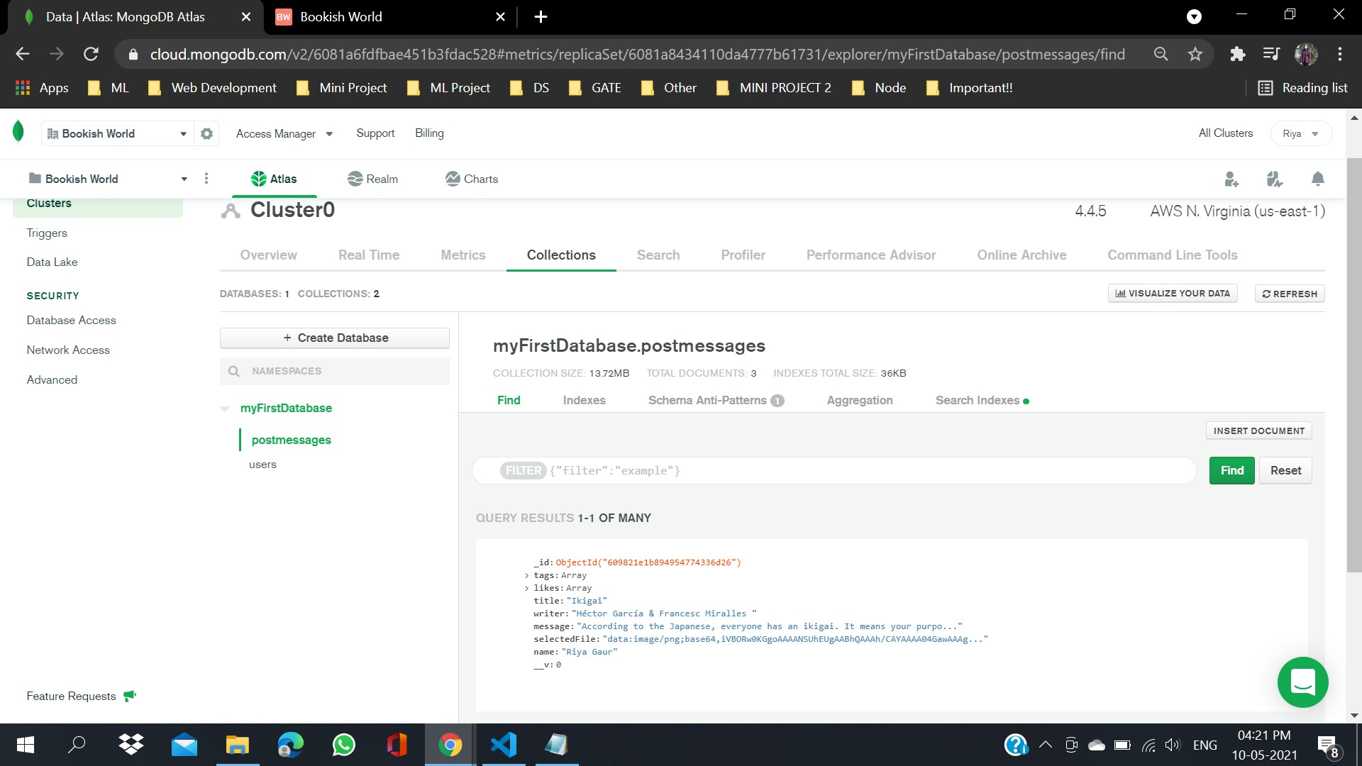

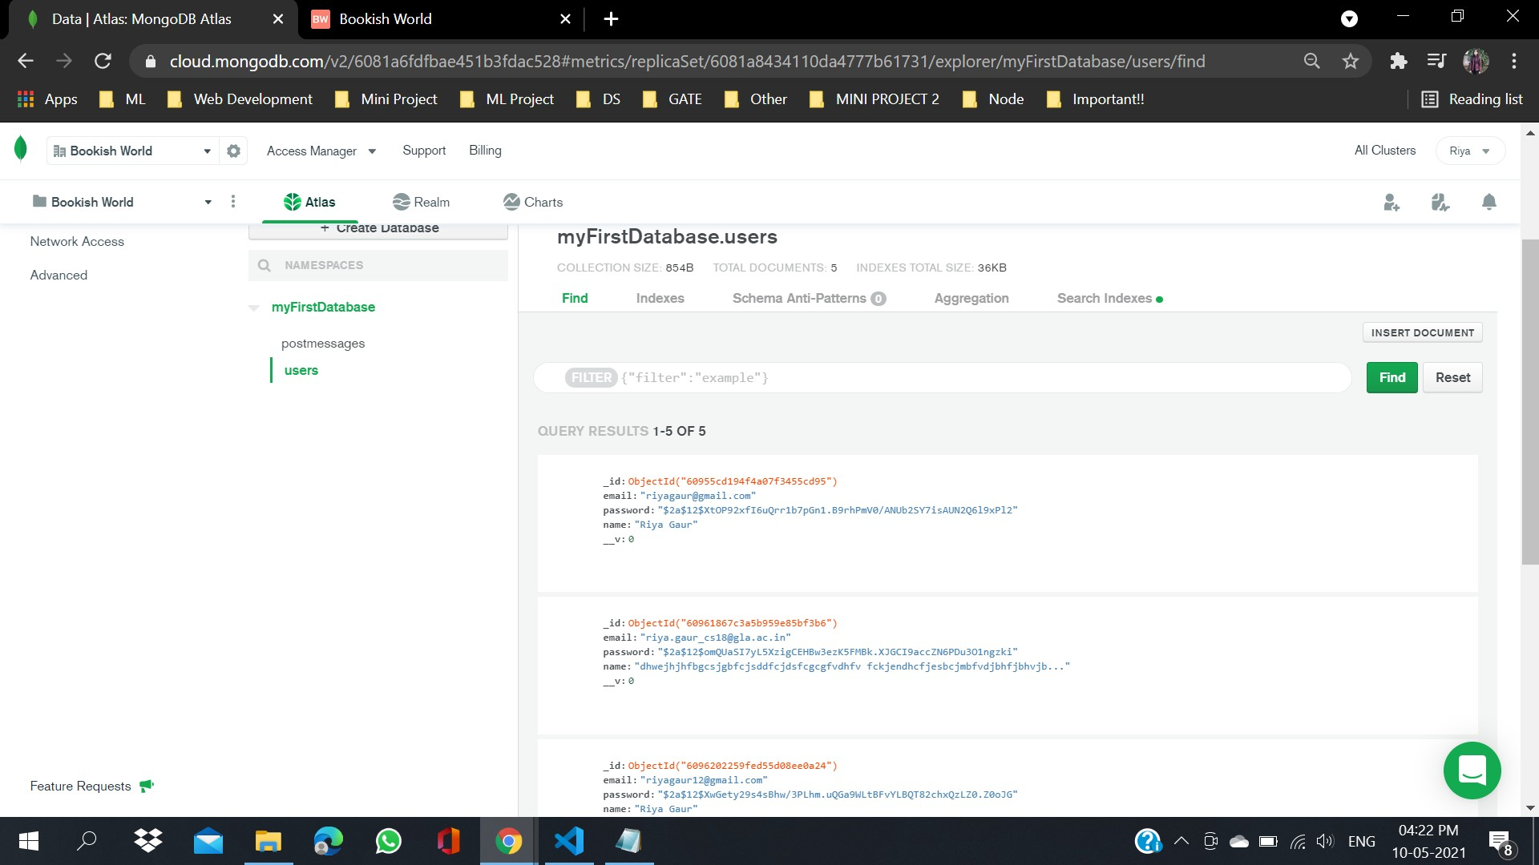

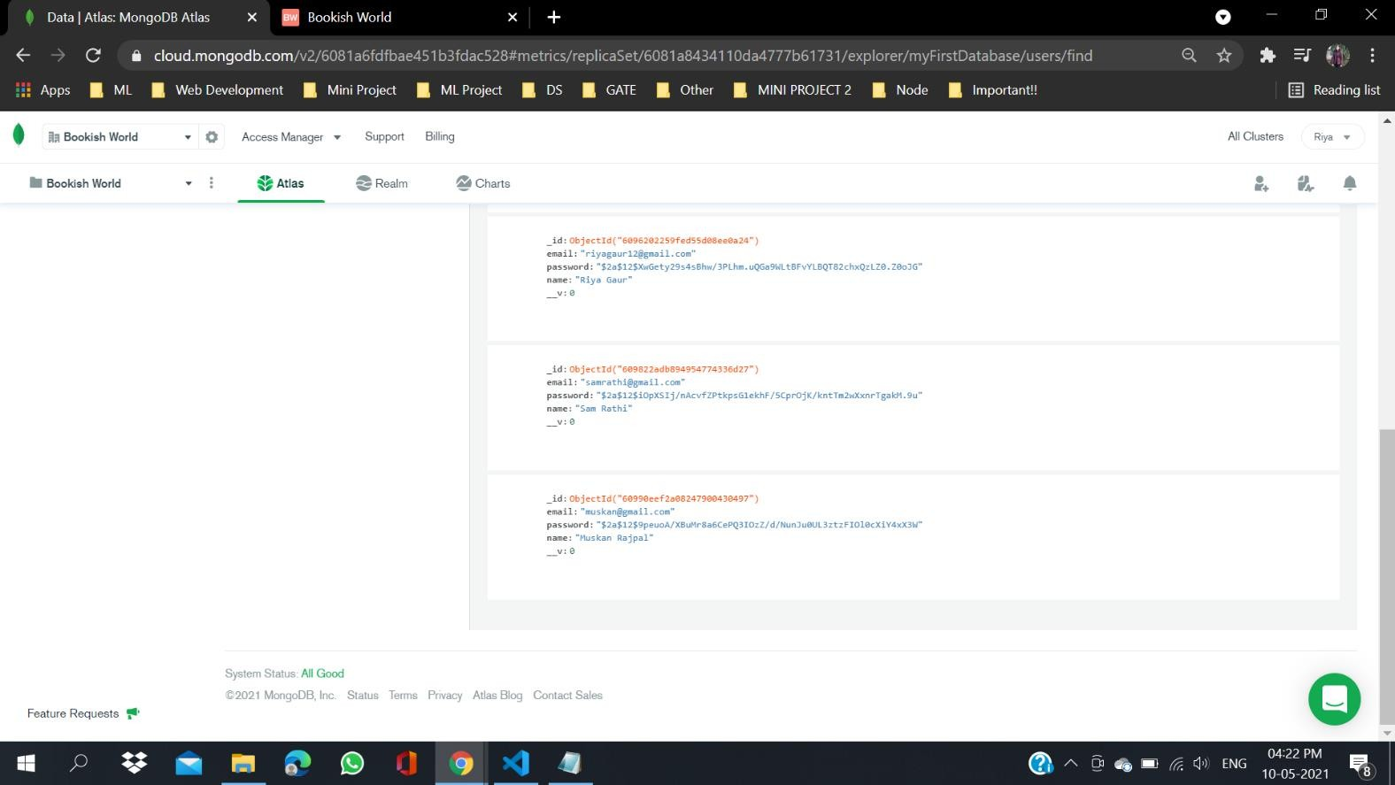

**FUTURE SCOPE**

Bookish World Project is a real time project which is useful for all the book lovers and readers as this helps in building a social media sort of platform where they get to explore new book titles, get to know what is the current choice of readers and which book has a different plot and aspect. They can like such sharable posts and also share their own experience of reading a particular book.

## LIMITATIONS OF THE SYSTEM PROPOSED

* It is one user interface website.
* The user can expect more features or want to gather more information.

## CONCLUSION

From proper analysis of positive points and constraints on the platform, it can be safely concluded that “Bookish World” is efficient UI based platform. This platform can be easily used in many other systems. Also, “Bookish World” is user friendly. Generally, readers do not get specific website where they can explore different book titles. This all information has to be managed manually. So, there is a need to develop a platform that can solve the mentioned problem. Thus, “Bookish World” comes with just that solution.

## REFERENCES:

### *www.javatpoint.com*

*www.w3school.com*

*www.tutorialspoint.com*

*www.youtube.com*

*https://web.learncodeonline.in/*

Book References-

Learning [React: Functional Web Development with React and Redux](https://www.amazon.com/Learning-React-Functional-Development-Redux/dp/1491954620?tag=javamysqlanta-20)

Faculty Mentor:

-Md. Farmanul Haque